**Food Delivery System**

**Software Requirements Specification**

Version 1.0

Index

1. DOCUMENT HISTORY 4

2. REFERENCES 4

3. DISTRIBUTION LIST AND APPROVALS 4

4. INTRODUCE 4

4.1 Purpose 4

4.1.1. Provide fast and convenient service 4

4.1.2. Improve user experience 4

4.1.3. Smart management system 4

4.1.4. Service quality assurance 5

4.2 Scope 5

5. OVERVIEW 5

5.1 Actor 5

5.2 Use Case Diagram 6

*5.2.1* Use Case Diagram - Guest 6

*5.2.2* Use Case Diagram - Customer 7

*5.2.3* Use Case Diagram - Restaurant 8

6. FUNCTIONAL DESCRIPTION 8

6.1. Login - Nam 8

6.2. Order booking 9

6.2.1. View Menu – Huy 10

6.2.2. Add to cart - Huy 10

6.2.3. Note food– Huy 11

6.2.4. Payment – Huy 12

6.3. Change password - Nam 12

6.4. Search and filter food 13

6.4.1. Search food - Tien 13

6.4.2. Filter food - Tien 14

6.5. Create comment 15

6.5.1. Create comment - Tien 15

6.5.2. View comment - Tien 16

6.6. Add to favourite list 16

6.6.1. Add to favourite list - Tien 16

6.6.2. View favourite list - Tien 17

6.7. Account Management 18

6.7.1. Ban/Unban Account - Anh 18

6.7.2. Decentralization Account - Anh 18

6.8. View Profile - Anh 19

6.9. View Order History - Anh 20

7. NON-FUNCTIONAL AND OTHER REQUIREMENTS 20

7.1. Non-functional requirements 20

7.1.1. Performance 20

7.1.2. Usability 20

7.2. Development environment requirements 21

7.2.1. Development Tools 21

7.2.2. Technology Stack 21

8. APPENDIX 21

# DOCUMENT HISTORY

|  |  |  |
| --- | --- | --- |
| **Date** | **Summary of Changes** | **Version** |
| 14/01/2025 | Software Requirements Specification | 1.0 |

# REFERENCES

|  |  |
| --- | --- |
| **Document Name** | **Description** |
|  |  |
|  |  |
|  |  |
|  |  |

# DISTRIBUTION LIST AND APPROVALS

|  |  |
| --- | --- |
| **Name** | **Title** |
|  |  |
|  |  |
|  |  |
|  |  |
|  |  |

# INTRODUCE

## Purpose

### Provide fast and convenient service

* Meet the needs of ordering and delivering food anytime, anywhere.
* Minimize ordering and delivery time.
* Support searching, filtering dishes and restaurants easily.

### Improve user experience

* Simple, user-friendly interface.
* Track order status in real time.
* Send notifications about order status (confirmed, preparing, delivering...).
* Provide reviews, comments and food suggestions based on customer preferences.

### Smart management system

* Support fast and accurate order processing.
* Store customer information and purchase history to serve marketing strategies.
* Integrate secure and convenient online payment systems (credit cards, e-wallets, cash...).

### Service quality assurance

* Build a system to check and evaluate the quality of food and delivery services.
* Provide support, return or refund policy if customers are not satisfied.

## 4.2 Scope

Software for online food and beverage delivery. The system specifically describes the tasks that need to be performed on the online ordering website, which can perform the following tasks: product management, account management, sales management, menu category management or management. There is also revenue management, invoice issuance, and statistical reporting.

# OVERVIEW

## Actor

|  |  |
| --- | --- |
| **Actor** | **Description** |
| Restaurant | Manage restaurant accounts.  Add, edit, and delete menu items.  Receive and process orders.  Update order status.  View sales reports and statistics. |
| Customer | Search for food/restaurant.  Register, log in, manage accounts.  Order, choose payment method.  Track order status.  Rate and feedback service. |
| Guests | View menu and prices  Search for food/restaurant. |

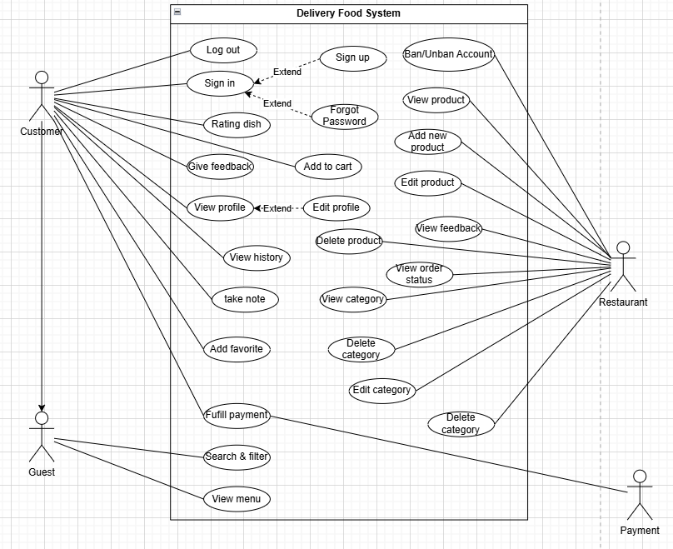

## Use Case Diagram

### Use Case Diagram - Guest

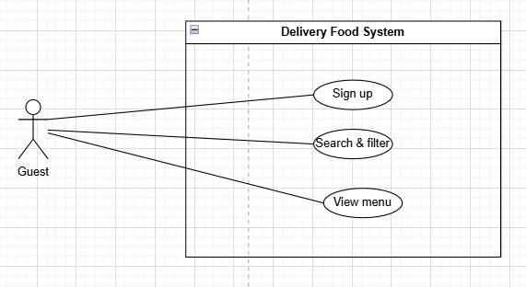

### Use Case Diagram - Customer

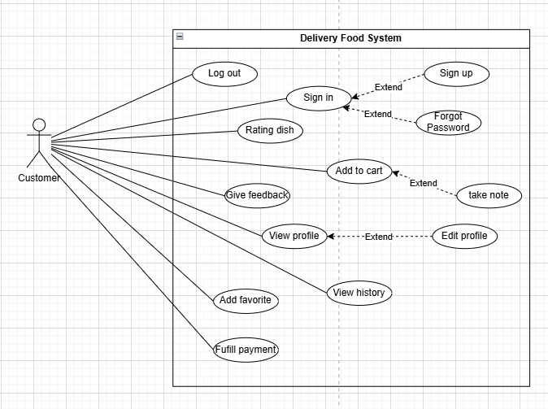

### Use Case Diagram - Restaurant

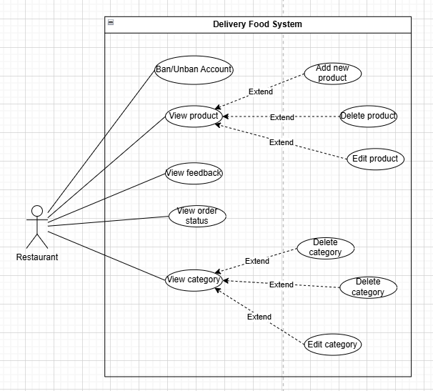

# FUNCTIONAL DESCRIPTION

## 6.1. Login - Nam

|  |  |
| --- | --- |
| **Use Case Name** | Sign in |
| **Use Case ID** | UC01 |
| **High Level Requirement Ref** | Users must log in to use the system's functions. |
| **Actor** | Admin and User |
| **Description** | Allows users to log in by entering username and password. |
| **Trigger** | The user selects the Login function on the system interface. |
| **Pre-condition** | Users must have a valid registered account.  User is not logged into the system. |
| **Post-processing** | If the login information is correct, the system will redirect the user to the home page and display functions based on their role.  If the login information is incorrect, an error message "Invalid username or password" will appear and the user will have to re-enter it. |

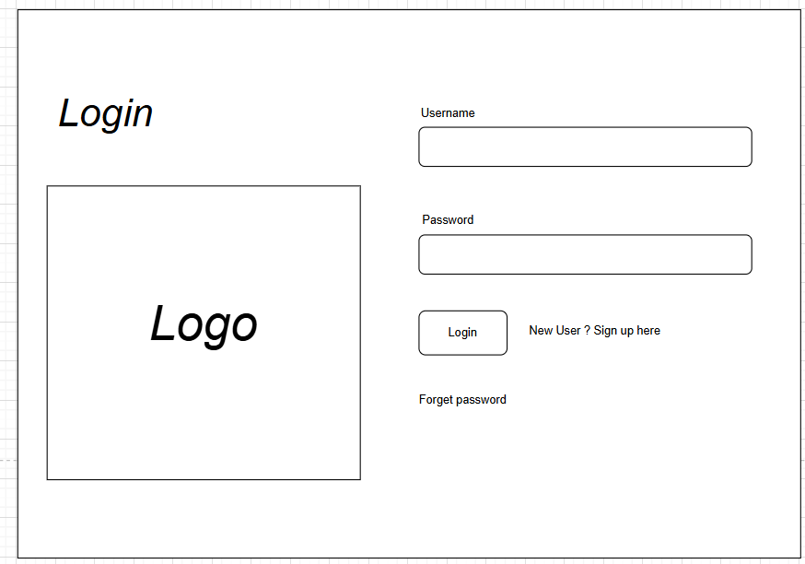

## 6.2. Order booking

|  |  |
| --- | --- |
| **Use Case Name** | Order booking |
| **Use Case ID** | UC02 |
| **High Level Requirement Ref** | The function allows customers to order online, customers can view the menu, add to cart and pay as well as note about the dish. |
| **Actor** | Customer |
| **Description** | Allow customers to view and order food |
| **Trigger** |  |
| **Pre-condition** | Users have to log in to the site. |
| **Post-processing** |  |

### 

### 6.2.1. View Menu – Huy

|  |  |  |  |  |  |
| --- | --- | --- | --- | --- | --- |
| **Screen** | View Menu | | | | |
| **Description** | | Display on the screen a list of all the restaurant's available dishes, customers can choose a category to display a list of corresponding dishes. | | | |
| **Screen Access** | | User clicks on menu ***Food And Drink*** | | | |
| **Screen Content** | | | | | |
| **Item** | | **Type** | **Data** | **Description** | |
| Category- ComboBox | | ComboBox |  | Select the desired food items listed in the comboBox | |
| **Screen Actions** | | | | | |
| **Action Name** | | **Description** | | **Success** | **Failure** |
| Category | | When the customer selects the desired food category, the website will query data from the database and list out food products with the corresponding category id. | | Display results. | Display “No data found” message |

### 6.2.2. Add to cart - Huy

|  |  |  |  |  |
| --- | --- | --- | --- | --- |
| **Screen** | Add to cart | | | |
| **Description** | Customers can select the corresponding product on the menu to add to the cart, after adding, users can adjust the desired quantity. | | | |
| **Screen Access** | User clicks on product in menu ***Food And Drink*** → ***Add to cart icon*** | | | |
| **Screen Content** | | | | |
| **Item** | **Type** | **Data** | **Description** | |
| Add to cart | Button |  | Add product to cart button | |
| Quantity | Text(25) |  | adjust quantity | |
| Back | Button |  | Return to previous screen | |
| **Screen Actions** | | | | |
| **Action Name** | **Description** | | **Success** | **Failure** |
| Add to cart | The system will redirect the user to the cart page. | | redirect to cart page |  |
| Quantity | Customers enter the quantity of products they want to buy, the system will check the format of the entered data and check if the quantity is valid with the quantity of products currently in the database. | | The system will confirm the quantity of products. | Notice:  invalid quantity |
| Back | Return to previous screen | | Return to previous screen |  |

### 6.2.3. Note food– Huy

|  |  |  |  |  |
| --- | --- | --- | --- | --- |
| **Screen** | **Note food** | | | |
| **Description** | Allow users to leave notes about the food ordered | | | |
| **Screen Access** | User clicks on menu ***Cart*** → ***Product*** → ***Note*** | | | |
| **Screen Content** | | | | |
| **Item** | **Type** | **Data** | **Description** | |
| Note field | Text field |  | Enter customer notes for the dish | |
| Save | Button |  | Confirm save note information | |
| Back | Button |  | Return to previous screen | |
| **Screen Actions** | | | | |
| **Action Name** | **Description** | | **Success** | **Failure** |
| Note field | Customers will enter notes about the dishes ordered. | | Show notes that customers have written |  |
| Save | The system will save the note information to the database. | | Show saved messages |  |
| Back | Return to previous screen | | Return to previous screen |  |

## 

### 6.2.4. Payment – Huy

|  |  |  |  |  |
| --- | --- | --- | --- | --- |
| **Screen** | **Payment** | | | |
| **Description** | Customers pay for the cart they have purchased. | | | |
| **Screen Access** | User clicks on menu ***Cart*** → ***Payment*** | | | |
| **Screen Content** | | | | |
| **Item** | **Type** | **Data** | **Description** | |
| Paypal QR |  |  | Display qr code for customers to pay | |
| Payment | Button |  | Confirm pay the cart | |
| Back | Button |  | Return to previous screen | |
| **Screen Actions** | | | | |
| **Action Name** | **Description** | | **Success** | **Failure** |
| Payment | When the user confirms the payment, the system will process the payment for the shopping cart through the link with payos, when the payment is successful, the system will update the payment status to the restaurant manager. | | Show success message | Show transaction failed message |
| Back | Return to previous screen | | Return to previous screen |  |

## 6.3. Change password - Nam

|  |  |  |  |  |
| --- | --- | --- | --- | --- |
| **Screen** | Change password | | | |
| **Description** | Display user information that needs to be changed | | | |
| **Screen Access** | User clicks on Profile -> Change password | | | |
| **Screen Content** | | | | |
| **Item** | **Type** | **Data** | **Description** | |
| Old password | Text field |  | Allow entry of current password | |
| New password | Text field |  | Allow new password entry | |
| Re-enter password | Text field |  | Allow re-entering new password | |
| Change | Button |  | When the user clicks on the “Change” button, the user’s password will be checked and if it satisfies the constraints, it will be changed to “New Password”. | |
| Reset | Button |  | Clicking this button will clear the “Old password”, “New password” and “Re-enter password” fields. | |
| Back | Button |  | Go back to previous screen | |
| **Screen Actions** | | | | |
| **Action Name** | **Description** | | **Success** | **Failure** |
| Change | When the user clicks on the “Change” button, the user’s password will be checked and if it meets the requirements, it will be changed to “New Password”. | | Change the user password in the system from “Old Password” to “New Password” | Error message: “Password must be at least 6 characters, including letters, numbers, and special characters”  Or “Incorrect password”,  Or “Re-enter password” must match “New password”  Or “New password must start with an alphabetic character” |
| Reset | Clicking this button will clear the “Old Password”, “New Password” and “Re-enter Password” fields. | | Clear the “Old password”, “New password” and “Re-enter password” fields |  |
| Back |  | | Go back to previous screen | |

## 

## 6.4. Search and filter food

### 6.4.1. Search food - Tien

|  |  |  |  |  |
| --- | --- | --- | --- | --- |
| **Screen** | Search food | | | |
| **Description** | In this interface, users can search for food items by entering the name of the food in the search box. | | | |
| **Screen Access** | Users click on the Function menu → Search Food | | | |
| **Screen Content** | | | | |
| **Item** | **Type** | **Data** | **Description** | |
| Food Name | Text field | Input text | Enter the name of the food to search. This field is mandatory. | |
| Search | Button | N/A | Click to perform the search for food items based on the entered name. | |
| Search Results | List view | List of food items | Displays a list of food items found based on the entered name. | |
| **Screen Actions** | | | | |
| **Action Name** | **Description** | | **Success** | **Failure** |
| Search | Function to search for food items by the entered name. | | The list of food items displays items matching the search. | Message: “No food items found.” |

#### 

### 6.4.2. Filter food - Tien

|  |  |  |  |  |
| --- | --- | --- | --- | --- |
| **Screen** | Filter food | | | |
| **Description** | In this interface, users can filter the list of available food items based on specific criteria to find their desired options more easily. | | | |
| **Screen Access** | Users click on the Function menu → Filter Food | | | |
| **Screen Content** | | | | |
| **Item** | **Type** | **Data** | **Description** | |
| Food Category | ComboBox | List of food categories | Select a category to filter the food items (e.g., appetizers, main courses, desserts). This field is optional. | |
| Price Range | Text field | Input price range | Enter the minimum and maximum price to filter food items. This field is optional. | |
| Rating | ComboBox | List of ratings | Select a rating level to filter food items. This field is optional. | |
| Filter | Button | N/A | Click to perform the filtering of food items based on the selected criteria. | |
| Filter Results | List view | List of food items | Displays a list of food items filtered based on the selected criteria. | |
| **Screen Actions** | | | | |
| **Action Name** | **Description** | | **Success** | **Failure** |
| Filter | Function to filter food items based on selected criteria. | | The list of food items displays items that match the filter criteria. | Message: “No food items found with the filter criteria.” |

## 6.5. Create comment

### 6.5.1. Create comment - Tien

|  |  |  |  |  |
| --- | --- | --- | --- | --- |
| **Screen** | Create comment | | | |
| **Description** | In this interface, users can create and submit comments about the food items they have experienced. | | | |
| **Screen Access** | Users click on the → Create Comment | | | |
| **Screen Content** | | | | |
| **Item** | **Type** | **Data** | **Description** | |
| Comment Content | Text area | Input text | Enter the content of the comment about the food item. This field is required. | |
| Rating | ComboBox | Rating options | Select a rating for the food item (1-5 stars). This field is required. | |
| Submit Comment | Button | N/A | Click to submit the comment. | |
| Result | Notification | N/A | Notification about the result of submitting the comment (success or failure). | |
| **Screen Actions** | | | | |
| **Action Name** | **Description** | | **Success** | **Failure** |
| Submit Comment | Function to submit a comment about the food item. | | Message: “The comment has been submitted successfully.” | Message: “Failed to submit the comment. Please try again.” |

### 6.5.2. View comment - Tien

|  |  |  |  |  |
| --- | --- | --- | --- | --- |
| **Screen** | View Comments | | | |
| **Description** | In this interface, users can view all the comments that have been submitted about the food items they are interested in. | | | |
| **Screen Access** | Users click on | | | |
| **Screen Content** | | | | |
| **Item** | **Type** | **Data** | **Description** | |
| Comments List | List view | List of comments | Displays a list of comments that have been submitted for the food item. Each comment includes content, rating, and the commenter's name. | |
| **Screen Actions** | | | | |
| **Action Name** | **Description** | | **Success** | **Failure** |
| View Comments | Function to display comments about the food item. | | The comments list displays the submitted comments. | Message: “No comments found.” |

## 6.6. Add to favourite list

### 6.6.1. Add to favourite list - Tien

|  |  |  |  |  |
| --- | --- | --- | --- | --- |
| **Screen** | Add to Favourite List | | | |
| **Description** | In this interface, users can add food items to their favorite list for easy access and searching later. | | | |
| **Screen Access** | Users click on Food | | | |
| **Screen Content** | | | | |
| **Item** | **Type** | **Data** | **Description** | |
| Food List | List view | List of food items | Displays a list of available food items to add to the favorite list. | |
| Add to Favorites | Button | N/A | Click to add the selected food item to the favorite list. | |
| Notification | Notification | N/A | Message about the result of adding the food item to the favorite list (success or failure). | |
| **Screen Actions** | | | | |
| **Action Name** | **Description** | | **Success** | **Failure** |
| Add to Favorites | Function to add a food item to the favorite list. | | Message: “The food item has been added to the favorite list.” | Message: “Failed to add the food item. Please try again.” |

### 6.6.2. View favourite list - Tien

|  |  |  |  |  |
| --- | --- | --- | --- | --- |
| **Screen** | View Favorite List | | | |
| **Description** | In this interface, users can view all the food items that have been added to their favorite list. | | | |
| **Screen Access** | Users click on the Function menu → View Favorite List | | | |
| **Screen Content** | | | | |
| **Item** | **Type** | **Data** | **Description** | |
| Favorite List | List view | List of favorite food items | Displays a list of food items that have been added to the favorite list. | |
| Search | Text field | Input text | Enter keywords to search for food items in the favorite list. This field is optional. | |
| Remove from Favorites | Button | N/A | Click to remove the selected food item from the favorite list. | |
| **Screen Actions** | | | | |
| **Action Name** | **Description** | | **Success** | **Failure** |
| View Favorite List | Function to display the food items in the favorite list. | | The favorite list displays the added food items. | Message: “There are no food items in the favorite list.” |
| Search | Function to search for food items in the favorite list. | | The favorite list displays the search results. | Message: “No food items found with the search keyword.” |
| Remove | Function to remove a food item from the favorite list. | | Message: “The food item has been removed from the favorite list.” | Message: “Failed to remove the food item. Please try again.” |

## 6.7. Account Management

### 6.7.1. Ban/Unban Account - Anh

|  |  |  |  |  |  |
| --- | --- | --- | --- | --- | --- |
| **Screen** | Ban/Unban Account | | | |  |
| **Description** | View Account, ban and unban account | | | | |
| **Screen Access** | At admin homepage, hover to admin menu to select Manager Account. | | | |  |
| **Screen Content** | | | | |  |
| **Item** | **Type** | **Data** | **Description** | |  |
| Ban | Button |  | Enter to lay off selected employee | |  |
| Unban | Button |  | Enter not to lay off selected employee | |  |
| **Screen Actions** | | | | |  |
| **Action Name** | **Description** | | **Success** | **Failure** |  |
| Select Account status | Admin Ban selected employee | |  |  |  |

### 6.7.2. Decentralization Account - Anh

|  |  |  |  |  |  |
| --- | --- | --- | --- | --- | --- |
| **Description** | Admin can Decentralization account | | | |  |
| **Screen Access** | At admin homepage can decentralization account of staff or customer | | | |  |
| **Screen Content** | | | | |  |
| **Item** | **Type** | **Data** | **Description** | |  |
| Status | Dropbox |  | Select Account status (Satff, Admin, Customer). Default is all status. | |  |
| **Screen Actions** | | | | |  |
| **Action Name** | **Description** | | **Success** | **Failure** |  |
| Select Account status | Admin select Account status | | View Account by selected status |  |  |

## 

## 6.8. View Profile - Anh

|  |  |  |  |  |  |  |
| --- | --- | --- | --- | --- | --- | --- |
| **Description** | | User can view their profile information | | | | |
| **Screen Access** | | Login to the system, at the navbar, hover mouse on welcome button near the cart icon then click view profile button | | | | |
| **Screen Content** | | | | | | |
| **Item** | | **Type** | **Data** | | **Description** | |
| Tên | | Label – string (50) |  | | Username that used to login into system | |
| Email | | Label – string (50) |  | | User email that used to login into system | |
| Số điện thoại | | Label – string (50) |  | | Phone number used to update personal information | |
| Giới tính | | Button |  | | Gender to fully supplement personal information | |
| Ngày Sinh | | Button |  | | Date of birth adds enough personal information to easily match teams to search for courses | |
| Tên ngân hàng | | Label – string (50) |  | | Button to let the system send information for payment | |
| Số tài khoản | | Label – string (50) |  | | Button to let the system send information for payment | |
| **Screen Actions** | | | | | | |
| **Action Name** | **Description** | | | **Success** | | **Failure** |
| View profile | User views their detail information in the user profile page | | | System displays all information to user | | Database connection is error => show notification “Server error” |

## 6.9. View Order History - Anh

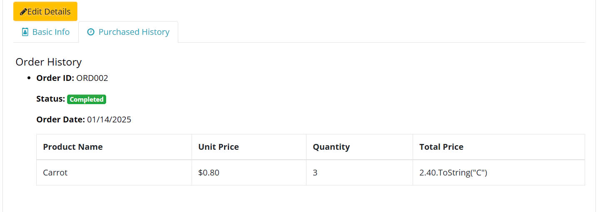

# NON-FUNCTIONAL AND OTHER REQUIREMENTS

## Non-functional requirements

### 7.1.1. Performance

#### - Response Time: The website should respond in under 5 seconds for 90% of requests.

#### - Handling number of concurrent users: The system must support at least 10,000 concurrent users during peak hours.

### 7.1.2. Usability

#### - The user interface (UI) should be friendly and simple, easy to use even for people with no experience in technology.

#### - The time to learn how to use the system should not exceed 15 minutes.

## Development environment requirements

### 7.2.1. Development Tools

#### - IDE: Visual Studio Code

#### - Source code management: Git (GitHub)

### 7.2.2. Technology Stack

#### - Frontend: HTML, CSS, JavaScript

#### - Backend: C#

#### - Database: SQL Server

# APPENDIX